
Project Design Phase-II
Technology Stack (Architecture & Stack)

Date | 27 January 2026
Team ID | LTVIP2026TMIDS28465
Project Name | ShopEZ: One-Stop Shop for Online Purchases
Maximum Marks | 4 Marks

Technical Architecture Overview
ShopEZ is a full-stack e-commerce platform built using the MERN stack (MongoDB, Express.js, React.js, Node.js). The architecture ensures scalability, modularity, and secure data flow between components.
Reference: https://github.com/sameekshaapatel/Shopez-E-commerce-
Applicationsameeksha/blob/main/README.md
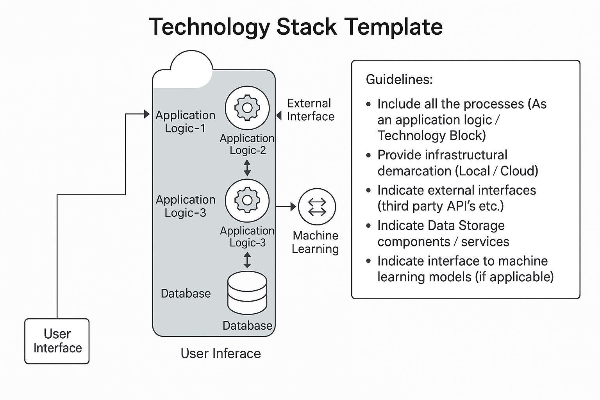
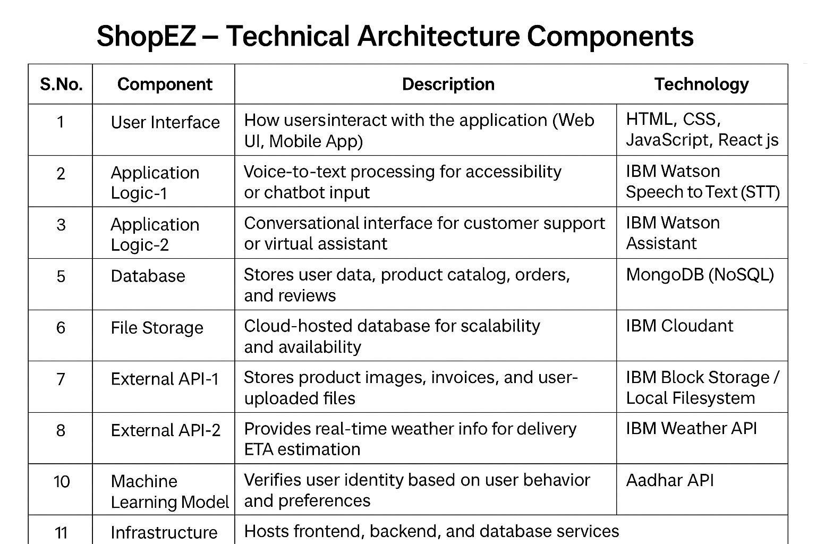

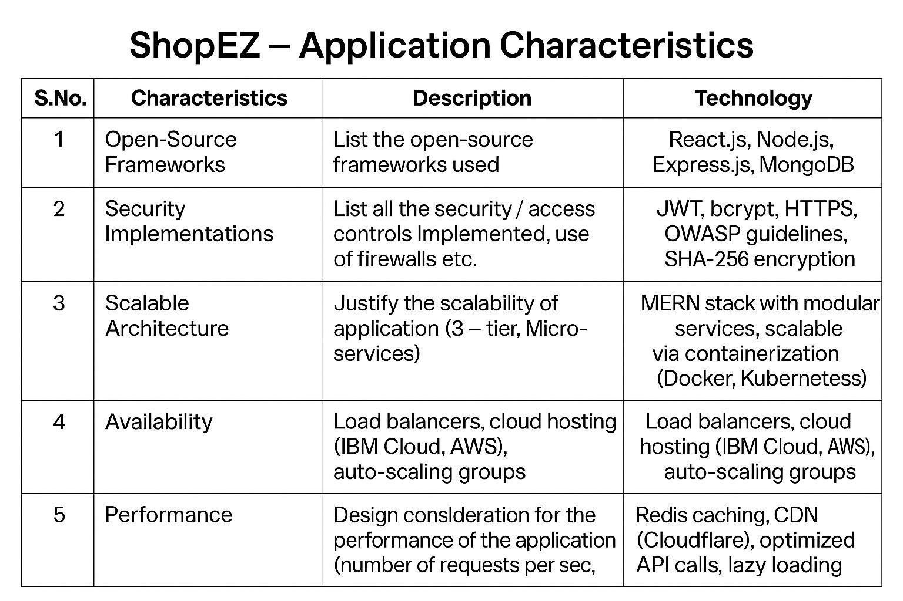

References https://c4model.com/ https://developer.ibm.com/patterns/online-orderprocessing-system-during-pandemic/ https://www.ibm.com/cloud/architecture https://aws.amazon.com/architecture https://medium.com/the-internal-startup/how-todraw-useful-technical-architecturediagrams-2d20c9fda90d https://github.com/sameekshaapatel/Shopez-E-commerce-
Applicationsameeksha/blob/main/README.md https://nme.smartinternz.com/saas-guidedproject/1/shopez-e-commerce-application https://www.cliffsnotes.com/studynotes/12909922

